1.

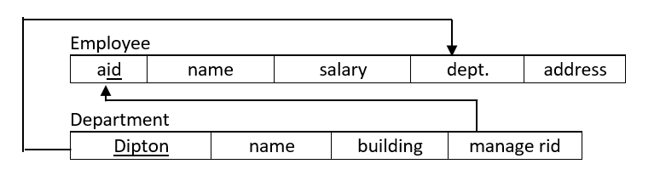

3.

a. SELECT name FROM Empolee

b. SELECT e.name

FROM Employee e, Department d

WHERE e.dept = d.deptNo and d.name=’Administration’;

c. SELECT e.name

FROM Employee e, Department d

WHERE e.dept = d.deptNo and d.name=’Administration’ and salary >50000;

d. SELECT e.name

FROM Employee e, Department d

WHERE e.eid = d.managerID;

e. SELECT e.name

FROM Employee e, Department d

WHERE e.eid = d.managerID and (d.dname=’Administration’ or d.dname=’Sales’);

f. SELECT e.name

FROM Employee e, Department d

WHERE e.eid = d.managerID and d.dname=’Administration’ and e.eid in (select e.eid

FROM Employee e, Department d

WHERE e.eid = d.managerID and d.dname=’Sles’);

Check 2 values in same column

i. SELECT d.dname, COUNT (e.eid)

FROM Employee e, Department d

WHERE e.dept = d.deptNo

GROUP BY d.deptNo, d.dname;

j. SELECT d.dname, COUNT (e.eid)

FROM Employee e, Department d

WHERE e.dept = d.deptNo

GROUP BY d.deptNo, d.dname

HAVING COUNT (e.eid) > 10;

k. SELECT e.id

FROM Employee

WHERE e.salary > ALL (SELECT e.salary

FROM Employee e, Department d

WHERE e.dept = d.deptNo and d.dname=’Sles’);

SELECT e.id

FROM Employee

WHERE e.salary > (SELECT MAX(e.salary)

FROM Employee e, Department d

WHERE e.dept = d.deptNo and d.dname=’Sles’);

l. SELECT e.id

FROM Employee

WHERE e.salary > ANY (SELECT e.salary

FROM Employee e, Department d

WHERE e.dept = d.deptNo and d.dname=’Sles’);

Subquery return more than one value we should use all, any operators

m. SELECT e.id

FROM Employee

WHERE e.salary >= (SELECT AVG(e.salary)

FROM Employee e, Department d

WHERE e.dept = d.deptNo and d.dname=’Sles’);

Here since subquery pass only one value, no need any, and operators